USB

Internship/Project Manual

Contents

- USB General Guidelines for Online Project & Internship for Fall 2021
- Guide to CV Preparation
- Internship Calendar
- BBA internship/project report writing guidelines
- Internship/Project Proposal Form
- Assessment Form for Host
- Plagiarism Declaration Form
- Internship/Project Report Cover Page
- Internship Report Approval Form

1

Checklist & Guidelines for Online

Project/Thesis/Internship for Fall 2021

for USB Provided by Career Services Office (CSO)

*Due to pandemic situation details may be changed*

- □ Sign-up with CSO for Project/Thesis/Internship: Student will fill up Google form for Sign Up. Sign Up form link: https://forms.gle/9G6mKS8hc1hYh1Yp8
- □ Registration for Project/Thesis/ Internship: Student will complete pre-registration through URMS after submitting your course completion checklist through BBA coordinator to Registrar Office. After Pre-registration you will get supervisor choice form & BBA Project & Internship Calendar.
- □ Collect Forwarding Letter for Internship from CSO: To send a Forwarding Letter to the Internship organization, Student will collect soft copy of the forwarding letter through CSO via email.
- □ Submit Letter of Acceptance from Internship Host to CSO: Student will send soft or scanned copy of Internship Organization’s Acceptance Letter to CSO and it must be endorsed/authorized by the Department internship coordinator or supervisor.
- □ Submit Project/Thesis/ Internship Proposal to CSO: Student will email soft copy of Project/Thesis/ Internship proposal to the assigned supervisor after approval of the supervisor, proposal will be sent to CSO at careerservices@ulab.edu.bd
- □ Plagiarism checking of Project/Thesis/Internship report: Student must check for plagiarism of the report. ULAB Library provides plagiarism check service through Turnitin. Student can send report to turnitin@ulab.edu.bd.
- □ Submit Soft Copy of Report to CSO: Student will mail Project/Thesis/ Internship report (soft Copy) to the assigned supervisor after plagiarism is being checked and approved by the supervisor, report will be emailed to CSO at careerservices@ulab.edu.bd
- □ Host Organization’s Evaluation: Host organization’s evaluation will be collected through email for internship students. (Student must provide organization’s email address to CSO and Department)

- □ Central Orientation, Departmental Orientation, Seminar, Meeting & Defense/Presentation: Central orientation, departmental orientation, seminar, meeting & defense/presentation will be held online (meeting platform and date will be announced via email as time proceed)
- □ Available Forms, Guidelines and Manual: Students are advised to download i) Intern Assessment Form (from Host), ii) Internship/Project Manual from the link: https://career.ulab.edu.bd/where-graduates-get-jobs/internship-information

Guide to CV Preparation

Do not use a fancy font – they are difficult to read and may put some employers off. Use standard fonts like 12 pt New Times Roman or 11 pt Arial. Use consistent formatting style. For example all headings should look similar (same size and type of font, same indentation, spacing, etc).

  - There is no hard-and-fast design template. Try to keep it to one-two pages. NEVER go beyond two pages.

You should highlight what is BEST about yourself, mention your achievements, but also don’t oversell yourself.

  - Be concise, use active verbs, do not have long sentences, try not to use abbreviations.

Start with the most recent employment and education details and work your way backwards.

  - Describe what you did using active verbs: "Taught" "Designed" "Implemented"

Don’t leave gaps between education and employment details. If you have been travelling or using time to volunteer make sure you mention it.

  - Use headings in bold type to help the reader navigate.

Do not use personal pronouns like “I” or “We” in the wording of the document.

  - Use courtesy titles when referring to people (such as your References). Eg. Dr. Anisul Islam, Mr. Fahad Rahman or Ms. Jahanara Anwar.

Keep the career objective brief, impersonal (don’t use “I” or “my”) and to the point. Don’t just put together several objectives you have read somewhere and liked the sound of. Long, complicated, objective statements put off the reader right at the beginning.

  - Do give examples of memberships of clubs and activities you participated in. These make you stand out among the crowd and show the employers who you really are.

Do not include names of your father and mother.

    - Do not include permanent address.

There is no need to mention height, weight, blood group etc unless you know these are needed for the job you would like to do. Personal information should be kept to a bare minimum. District, etc, are not necessary.

  - Do mention your expected date of graduation.

Know when to use capital letters. Always use capitals in names of people, schools, colleges and places (Eg. University of Liberal Arts Bangladesh not University of liberal arts Bangladesh)

  - Do not use abbreviations such as “&”. Use the full form of the word – “and”. Remember that the CV is a formal document.

Do not include personal qualities, as they are your opinions, not necessarily facts about yourself (eg innovative, hard working, goal oriented). Put emphasis on facts in the CV. Emphasis what you did, what your achievements, activities and interests have been over the last few years.

  - Put a simple border (nothing fancy!) around your digital photograph.

  - It goes without saying that everything you mention in the CV needs to be accurate and true. There is no need to sign off on the CV with statements such as “All information given in this CV is accurate to the best of my knowledge”.

Leave lots of white space.
  - Make sure you spell check.

NEVER LIE!

Farhana. Q. Student
House 56, Road 4A @ Satmasjid Road Dhanmondi, Dhaka 1209
Email: f.q.s@hotmail.com Mobile: +880-171-111-2222

Objective
To serve in a media house, in a well-fitted position and develop my career in news reporting section.

Professional Experience

April 2009-Documentary on Seed Collection and Preservation
- Assisted cameraman , shot footage , operated boom and recorded sound
- Took photos of subjects at work on SLR digital camera.

July 2008- Documentary film on ‘Water Pollution’
- Created the original concept about the story.
- Took photos of subjects at work on SLR digital camera.

February 2008 - Documentary film on ‘21st February’

∙  ∙ | Shot footage on HDV video camera  Interviewed sources
∙ | Wrote Bangla language script detailing history and culture of February. | Ekush ey

Education
BSS in Media Studies & Journalism : Graduating Fall 2010 (Concentration in Journalism) CGPA 3.93 out of 4.00 University of Liberal Arts Bangladesh

H.S.C Humanities group : 2006, CGPA 4.50 Dhaka College

S.S.C Science group : 2004, CGPA 3.83 Model Academy Mirpur

Language Skills
Fluent in Bangla and English.

References
M. Professor, Assistant Professor Media Studies & Journalism University of Liberal Arts Bangladesh House 56, Road 4/A, Dhanmondi
E-mail:

Z. Lecturer, Lecturer
Media Studies & Journalism University of Liberal Arts Bangladesh House 56, Road 4/A, Dhanmondi
E-mail

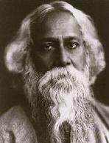

Md. Q. Student

House 56, Road 4A @ Satmasjid Road, Dhanmondi, Dhaka 1209. Cell: +880 171 222-3333 Email: md_q_student@hotmail.com

Objective:
A highly self-motivated individual, inspired to work in the media sector to build up a successful career in a reputed organization, using experience I have acquired in my academic and professional career.

Professional Experience:
June 2009 –February 2010: Photographer for Shwapno Abashan (Monthly Magazine) Took photos, interviews, edit photos in Photoshop CS3, gathered information, communicated with teammates.

2009: Assistant Director, Cameraman & Editor of student projects, ULAB
Assisted the Director, captured video on professional Sony HDV camera, edited in Macintosh Final Cut Pro.
August 2008-March 2009: Photographer for The Daily Shomokal (“NANDAN” Page) Took photos, edited photo in Photoshop CS2, communicated with colleagues and supervisors.
2006-2007: Assistant Director & Producer, MV of Shubir Nondi under Shangita Music Assisted the Director, fixed shooting locations, arranged props, and managed the whole team in Cox’s Bazaar.

Academic Qualifications:
- Currently studying BSS (Hons.) in Media studies and Journalism in the University of Liberal Arts Bangladesh (ULAB), Term 11th. (CGPA-3.93).

- Completed Higher Secondary Certificate from Dhaka Commerce College, under Dhaka Education Board in 2005 from Business Studies with GPA 4.10.

- Completed Secondary School Certificate from University Laboratory School and College, under Dhaka Education Board in 2003 from Business Studies with GPA 4.00.

Language Skills:
Fluent in Bangla. Good speaking, reading & writing knowledge of English.

IT Skills:
Basic computer operating skills with Office Management & Microsoft Office. Basic photo editing and illustration, using Adobe Design Pack.

7

References:
M Professor, Assistant Professor Department of Media Studies and Journalism University of Liberal Arts Bangladesh
Tel.

Dr. Professor, Professor Department of Journalism University of Dhaka Phone:

8

Calendar for Project and Internship: Fall 2021

ULAB School of Business
‘Due to pandemic situation dates & details may be changed'

Sl. | Event | Details | Date | Remarks
1 | Supervisor Assign | Assignment of Supervisor | 4/10/21
2 | Sign Up form Fill Up | Student will fill up Google form for Sign Up. Sign Up form link: https://forms.gle/6nfb3mAZMRaLvDQq9 | Deadline 14/10/21
3 | Seminar | Internship/Project Proposal and Report Writing Guidelines: Fall 2021. | 28/10/21
4 | Submission of Acceptance letter | Send letter of acceptance (Soft/Scan Copy) from your Internship organization to CSO. (careerservices@ulab.edu.bd) | Deadline 31/10/21
5 | Proposal Submission | E-mail Project/internship proposal (soft Copy) to assigned supervisor. After approval, supervisor will send it to careerservices@ulab.edu.bd | Deadline 11/11/21
6 | Internship/Project Meeting | Internship/Project Mid review | 15/12/21
7 | Draft Copy for  Review | E-mail a draft copy of final report to your Supervisor. | 13/1/22
8 | Submission of Final Report | FOR INTERNSHIP & PROJECT STUDENTS:  Submit the soft copy in PDF Format in one single file to your supervisor. After checked and approval supervisor will send it to careerservices@ulab.edu.bd | 30/1/22 | No extension of the report submission date will be given under any circumstances.
9 | Evaluation Report by Host Organization | For intern students’ Submit host organization evaluation / assessment scanned form duly signed by host organization supervisor and must be sent by him to  (careerservices@ulab.edu.bd) | 30/1/22
10 | Seminar for defense grooming | Internship /Project Defense Grooming Session: How to face? | 3/2/22
11 | Defense | Internship Defense will be held with a Panel of Faculties, consisting 3 to 4 members. | 6/2/22

INTERNSHIP/PROJECT REPORT GUIDELINES

Introduction

The Internship Program carries six credits, equivalent to two full credit courses. Therefore, the same rigor should be applied to prepare the internship report as for any other course. The internship report is likely to be read by potential employers; therefore, it is very important that the grade it receives is commensurate with its quality. The internship final report should be a formal document written in prose that summarizes the internship experience. You are expected to write in first-person and avoid third-person style of writing. Reports should be your own work and not plagiarised.

Report writing guidelines

1 | Page | Should be of A4 size
2 | Font | Times New Roman, 11
3 | Colour | Black & White  No colour printing (except for graphs, charts etc.) No picture, colour pages or logo/watermark in page making
4 | Spacing | The body of the report should have 1.5 line spacing
5 | Margin | 1.5 inch/3.8 cm all round
6 | Word/page Limit | Maximum 25 standard pages(A4, 1.5 inch margin, Times New Roman 11 font in the body, 1.5 line gap)  including everything (cover to cover)
7 | Logo and picture | Do not include too many, be concerned about the  copyright issues. May be used or include only when they really matter.
8 | Report objectives | Maximum 3 in number, better to be one, should be  relevant and achievable within the time frame
9 | Sampling | Should be well thought out, appropriate, and adequate
10 | Consistency | Report objectives, methodology, and findings should be  well aligned and rightly linked to each other
11 | Referencing style | All references and citation must conform to Harvard System of Referencing. For reference, visit:  h ttp ://lib w eb .an glia.ac.u k/referen cin g/h arvard .h tm
12 | Plagiarism | Be very careful not to submit an extensively plagiarised report. You will be required to submit a soft copy of your report/thesis at the time of submission of the hardcopy. The soft copy shall be used to check the amount of its plagiarised or copy/paste contents. For extensive plagiarism, where, for instance, the project part has been copied, you should be given a failing. For lower instances of plagiarism, the examiners can decide on penalty, such as re-write and re-submission, reduced marks/grades, etc.

8

Internship report format
Cover/Fly

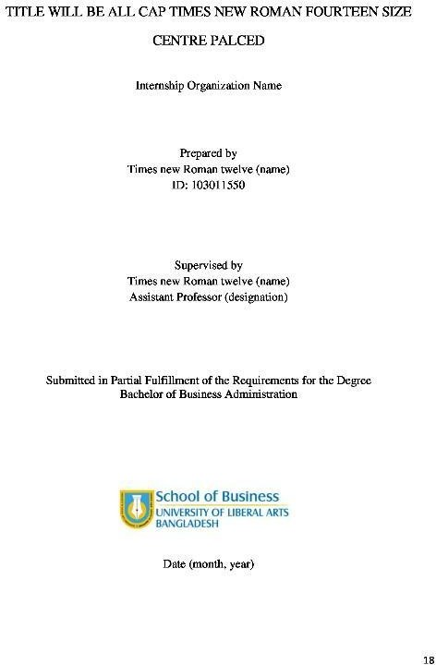

Title Page Approval form Declaration
Letter of Transmittal

Executive Summary Table of content
Pa rt A : Internship E x perience (10 -12 p ages)
Chapter One: Organization Profile
Industry analysis (Five Forces Model if applicable)

(SWOT Analysis)
Financial performance analysis (for listed companies)

Chapter Two: Interns Role and responsibility
Chapter Three: Observations
Pa rt B : R esea rch Project (no t mo re th an 12 p ages exclud in g app ended pages)
Chapter One: Research Design
Background/Statement of the problem/why this topic is important Objective(s) of the project
Main research question(s)

(How you conducted the study / research) Methodology
Type of research: Primary, secondary or mixed
If survey use, explain sampling method Discus about data source
Discuss about method of collective data/information
If interviews used, explain

Chapter Two: Theoretical Background (if applicable)

Chapter Three: Analysis and Findings
Chapter Four: Conclusion and Recommendations (if applicable)

Chapter Five:
References Appendices Exhibits
Tables/Graphs/Charts
Questionnaire (if survey / interview used)

Project report format

Cover/Fly

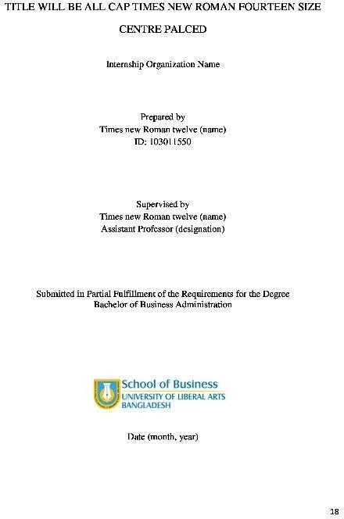

Title Page Approval form Declaration
Letter of Transmittal Abstract
Table of content
Chapter One: Introduction
Background/Statement of the problem/Why this topic is important Objective(s) of the project

Main research question(s)

(How you conducted the study / research) Methodology
Type of research: Primary, secondary or mixed If survey use, explain sampling method
Discus about data sources

Discuss about method of collective data/information

If interviews used, explain

Chapter Two: Theoretical Background (if applicable)
Chapter Three: Organizational profile/Industry mapping/descriptive report Chapter Four: Analysis and Findings

Chapter Five: Conclusions and Recommendations (if applicable)

Chapter Six:
References Appendices Exhibits
Tables/Graphs/Charts Questionnaire (if survey/ interview
used)

Best of luck!

CS001
INTERN ASSESSMENT FORM
(To be filled up by Internship Organization)

ULAB ID:

Name of Intern:
Host organization Supervisor: Designation: Organization:

Using the following scale please assess the intern on the criteria listed below:

KEY: 5 = Excellent 4 = Very Good 3 = Good 2 = Satisfactory 1 = Not Satisfactory

Performance Criteria | 5 | 4 | 3 | 2 | 1 | Unable to Assess
Time Management
Communication Skills
Ability to Work in Team
Ability to Work Independently
Leadership Skills
Self Motivation
Commitment to the Task Assigned
Creativity

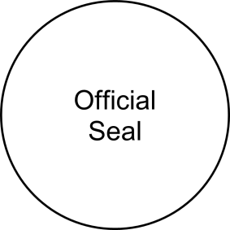
Comments on where the intern can improve:

Signature of Supervisor & Date:

Please send the completed form in a sealed envelope to:
Career Services Office, University of Liberal Arts Bangladesh
House # 56, Road # 4/A, Dhanmondi, Dhaka – 1209, Bangladesh Tel: 9665686, 9661255, 01711298916

CS001 (00) Page 1 of 1

CS003

INTERNSHIP PROPOSAL FORM

Name :

ID :

Department :

Supervisor’s name :
(Faculty)

Organization name :

Internship title :

Student’s signature & date: Supervisor’s signature & date:

(Submit your Research Proposal to your Supervisor for approval)

CS022
[Type here]

PROJECT PROPOSAL FORM

Name :

ID :

Department :

Supervisor’s name :
(Faculty)

Project title :

Student’s signature & date: Supervisor’s signature & date:

(Submit your Research Proposal to your Supervisor for approval)

CS007

PLAGIARISM DECLARATION

I know that plagiarism means taking and using the ideas, writings, works or inventions of another as if they were one’s own. I know that plagiarism not only includes verbatim copying, but also the extensive use of another person’s ideas without proper acknowledgement (which includes the proper use of quotation marks). I know that plagiarism covers this sort of use of material found in textual sources and from the Internet.

  - I acknowledge and understand that plagiarism is wrong.

I understand that my research must be accurately referenced.

  - This assignment is my own work, or my group’s own unique group assignment. I acknowledge that copying someone else’s assignment, or part of it, is wrong, and that submitting identical work to others constitutes a form of plagiarism.

I have not allowed, nor will I in the future allow, anyone to copy my work with the intention of passing it off as their own work.

Name (BLOCK LETTERS) ULAB ID #

Signature Date

TITLE WILL BE ALL CAP TIMES NEW ROMAN FOURTEEN SIZE CENTRE PALCED

Internship Organization Name

Prepared by
Times new Roman twelve (name) ID: 103011550

Supervised by
Times new Roman twelve (name) Assistant Professor (designation)

Submitted in Partial Fulfillment of the Requirements for the Degree Bachelor of Business Administration

Date (month, year)

IMPACT OF FINANCIAL MARKET CRISIS ON THE PERFORMANCE OF ISLAMIC AND CONVENTIONAL BANKS OF BANGLADESH

Internship Organization Name

Prepared by Name ID:

Supervised by Teacher’s Name Designation

Submitted in Partial Fulfillment of the Requirements for the Degree Bachelor of Business Administration

September 2018

CS002

Internship Report Approval Form

Student Name ID No.

Major: Year:

Mobile Phone: Email:

INTERNSHIP/PROJECT INFORMATION

Internship

Organization:

Internship /Project Report Topic:

Term (Tick one): □ Spring 2021 □ Summer 2021 □ Fall 2021

SUPERVISOR APPROVAL
(Tick One)

□ Approved □ Not Approved □ Partial Re-write □ Full Re-write

Remarks (For Not Approved):

Signature: Date:

Name:

E-mail:

Phone:

